Divide and Conquer Foreign Policy: Ch. 17 in Patterson
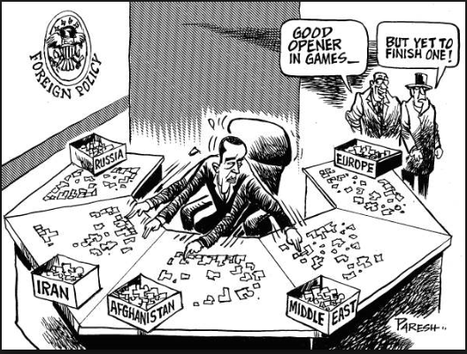
We will divide and conquer Ch. 17 in Patterson. Your classmates are counting on you to do your reading this weekend! There will be a special assignment for students who do not read and cannot contribute to their group’s “Storyboard” assignment which we will complete in class on Monday 11/4 (3rd & 8th) and Tuesday 11/5 (5th). Don’t forget that our Full Legislative Session is on Monday 5th – 7th. Please meet in the auditorium 5th hour and sit with your committee! Please continue to bring your book to class every day. Thanks!
Reading #1: pgs. 501- 504 (The roots of US Policy)
Reading #2: pgs. 504 (bottom) – 509 (War on Terrorism)
Reading #3: pgs. 509 (middle) – the top of 514 (Military Dimension)
Reading #4: pgs. 514 – 517 (Economic Dimension)
Reading #5: pgs. Bottom of 517 – 520 (Promoting Global Trade)
Reading #6: pgs. 499 – 510 (chapter intro) & 520 – 522 (A New World)
Reading #7: Libya Reading NYT
Reading #8: Middle East Reading NYT

Divide and Conquer Foreign Policy: Ch. 17 in Patterson
We will divide and conquer Ch. 17 in Patterson. Your classmates are counting on your to do you reading this weekend! There will be a special assignment for students who do not read and cannot contribute to their group’s “Storyboard” assignment which we will complete in class on Monday 11/4 (3rd & 8th) and Tuesday 11/5 (5th). Don’t forget that our Full Legislative Session is on Monday 5th – 7th. Please meet in the auditorium 5th hour and sit with your committee! Please continue to bring your book to class every day. Thanks!
Reading #1: pgs. 501- 504 (The roots of US Policy)
Reading #2: pgs. 504 (bottom) – 509 (War on Terrorism)
Reading #3: pgs. 509 (middle) – the top of 514 (Military Dimension)
Reading #4: pgs. 514 – 517 (Economic Dimension)
Reading #5: pgs. Bottom of 517 – 520 (Promoting Global Trade)
Reading #6: pgs. 499 – 510 (chapter intro) & 520 – 522 (A New World)
Reading #7: Libya Reading NYT
Reading #8: Middle East Reading NYT

